Music Manager

The goal of the exercise is to make a music manager application. A music manager application allows you to browse through a music library, add new entries and delete them (so the usual Create, Update and Delete stuffs (CRUD)).
All music data should be stored server side in a database. The client should be a web client. Communication between clients and server should go over REST.
On the server side we expect the application to be deployed in a Tomcat server. The client should always communicate to one dedicated service interface (MusicManagerService). The MusicManagerService implementation is a POJO which is using Spring to interact with the database.
How should the GUI look?
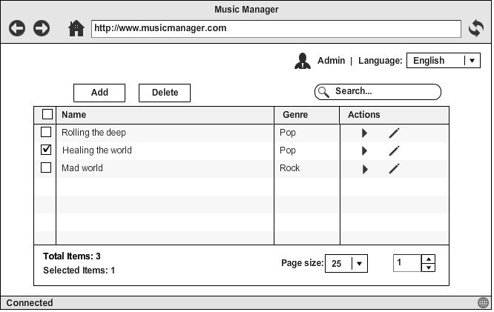
The GUI can be very basic: a table which lists all music files. There should be an action bar with 'Add’ (which leads to ‘Add Song’ page mentioned below), ‘Delete’ buttons and a Search box.
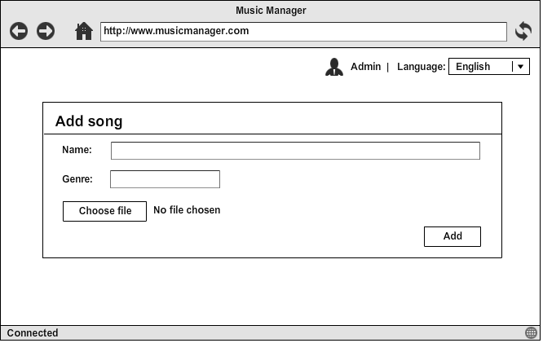
We also need to support ‘Play’ and ‘Edit’ modes for each song, as followings:
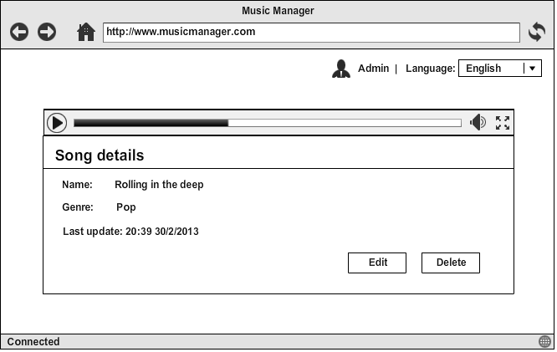
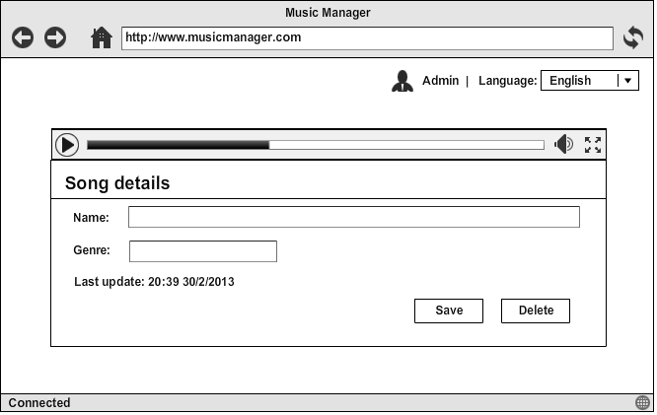

Technology requirements

SERVER

CLIENT
RESTFUL web-service
Technologies need to be used:
- Javascript
- AngularJS (MVC)
- Twitter Bootstrap
- HTML5/CSS3
- JSON

Nice to have:
- Unit-testing (Jasmine, Karma)
- Localization (L10n) and Internalization (i18n)
- Multi-browser support (Firefox, IE, Safari, Chrome…) => just an improvement
Technologies need to be used:
- Spring
- Spring Data Mongo (Transaction, Mapping, Paging)
- Spring MVC
- MongoDB, Mongo Template & Tomcat
- Or Hibernate, MySQL

Nice to have:
- Spring Security (Login)
- Notifications to the clients

